Non-Relational Data Management

MPe07 - GridFS

**Name: _____________________________________________**

In this practice exercise, you will be running MongoDB commands to create a GridFS Database.

1. Pick two images of your choice, or other large objects (audio, video, pdf,…) from the Internet or elsewhere.
2. Store the images in a MongoDB GridFS database using the mongofiles command (OS command)

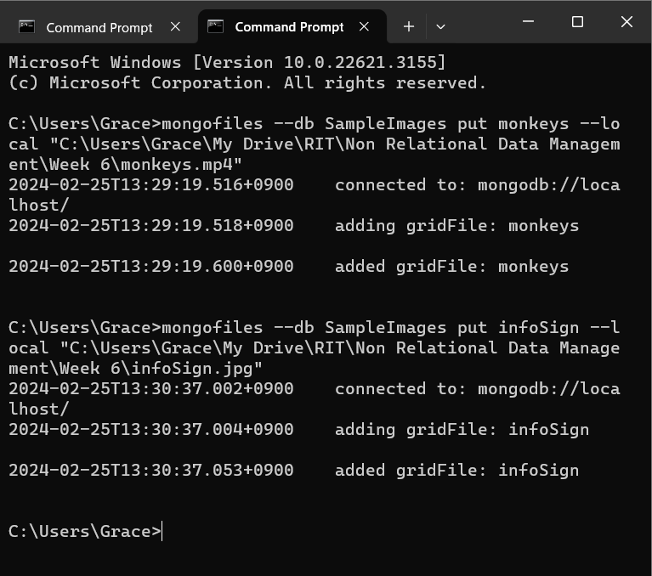

1. Use the mongofiles command to list the items in the database.

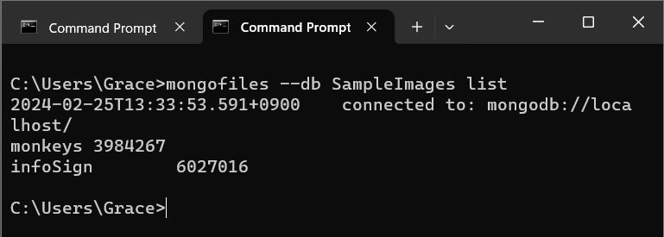

1. Retrieve the images from the MongoDB GridFS database and store them in another spot on the file system.

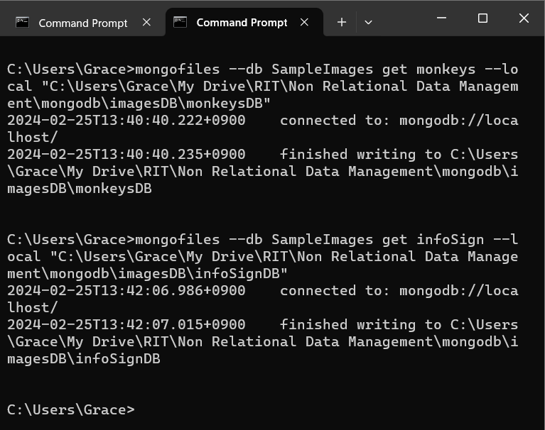

1. Using the find() and pretty() command, display the fs.files collection.

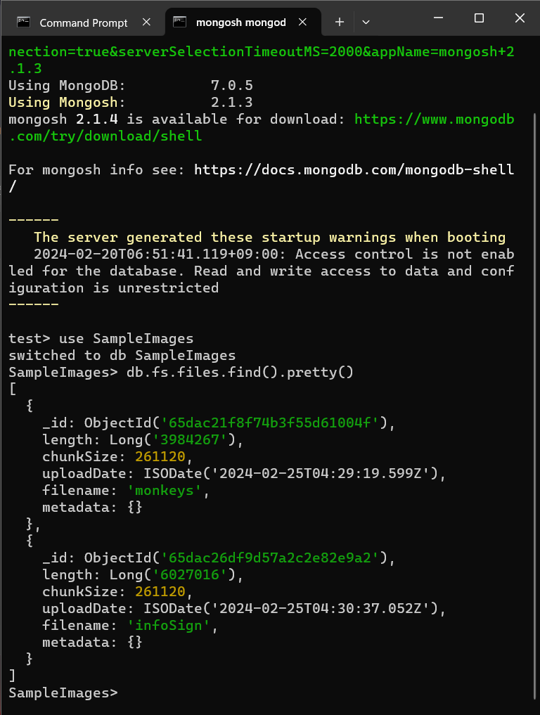

1. Using the find(), pretty() and limit() command, display 20 documents in the fs.chunks collection. **Show only the _id, files_id, and the number of the chunk**.

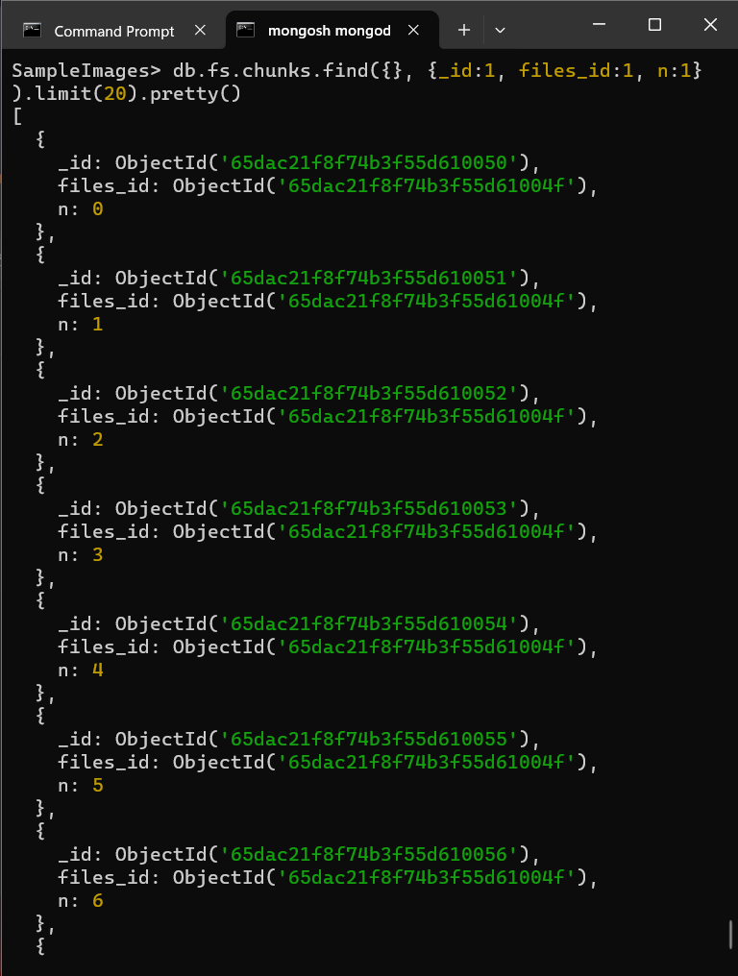

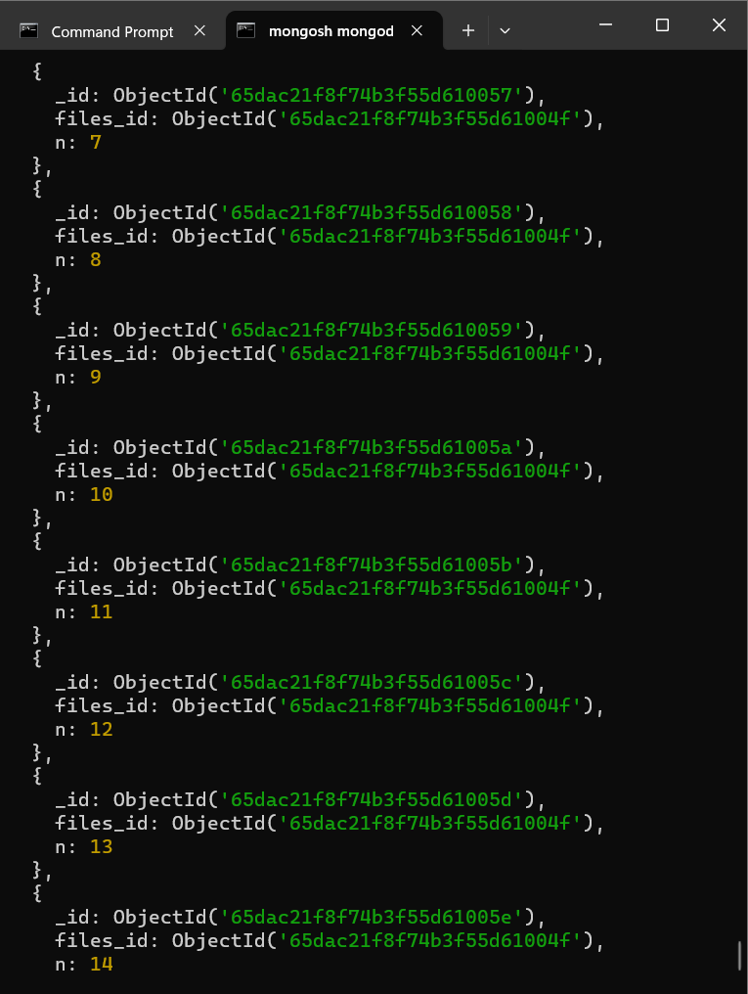

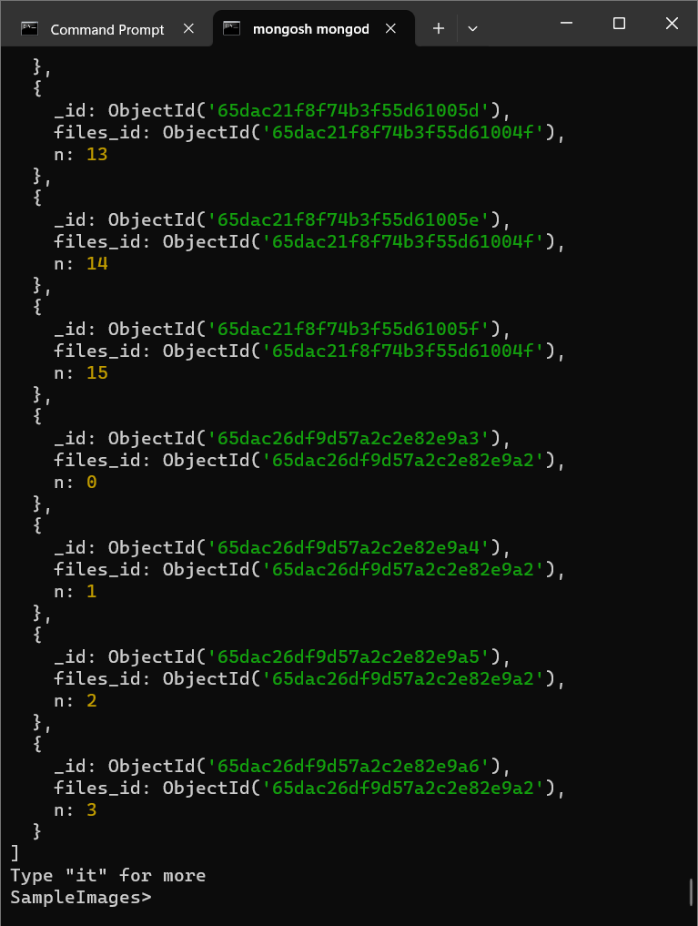

Paste the results of the query into this MS Word document and submit it to the dropbox. Do not zip the file.

**Submit the MS Word document to the MPe07 Assignment folder when the PE is completed.**